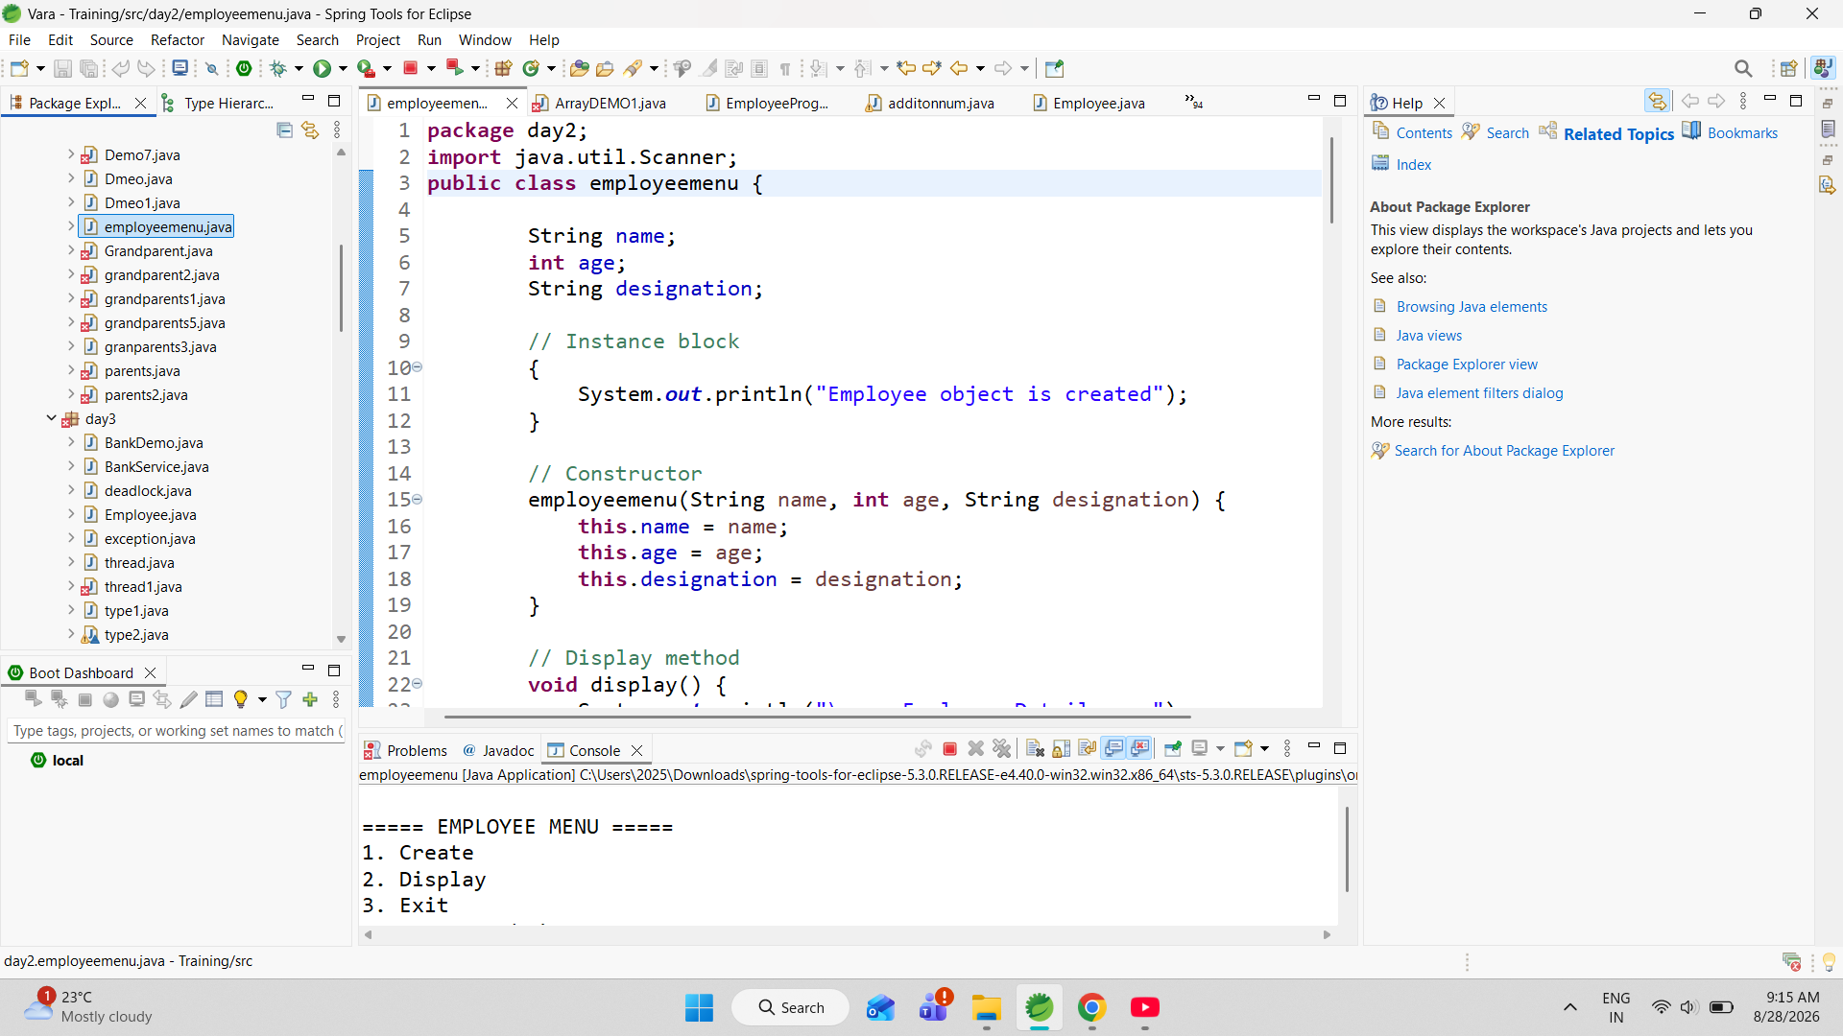

The Employee Menu Program is a simple Java-based application developed to manage basic employee information. The main purpose of this program is to provide an interactive menu through which the user can create an employee and view the stored employee details. The program stores important employee information such as name, age, and designation. It uses a class and object-based approach, making it a good example of basic Object-Oriented Programming (OOP) in Java.

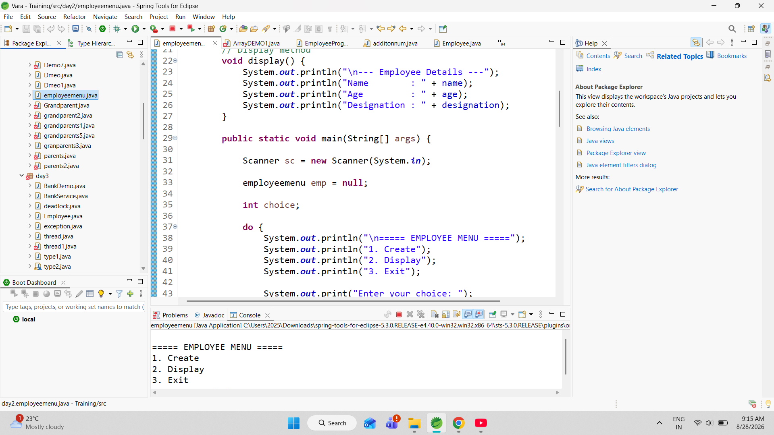

The program provides three main options: Create, Display, and Exit. While creating an employee, the program accepts the employee's name and age from the user and performs validation to ensure that the name contains exactly two words and the age is between 18 and 60 years. The user can then select a designation such as Programmer, Manager, or Tester. Once valid information is entered, an employee object is created using a constructor. The program also uses an instance initialization block, the this keyword, methods, if-else, switch-case, while, and do-while statements.

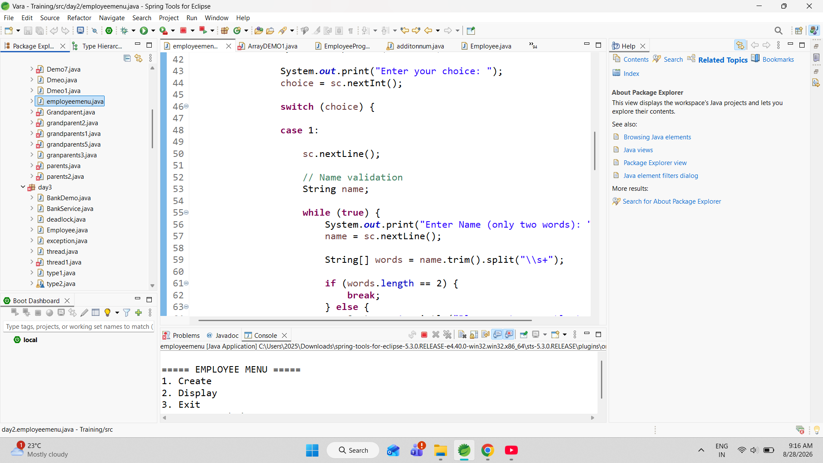

The application demonstrates how Java can be used to combine data, object creation, user input, validation, and program control flow in a single application. The display() method is responsible for showing the stored employee information, while the menu allows the user to perform operations repeatedly without restarting the program. The use of emp != null ensures that the program does not attempt to display employee details before an employee has been created.

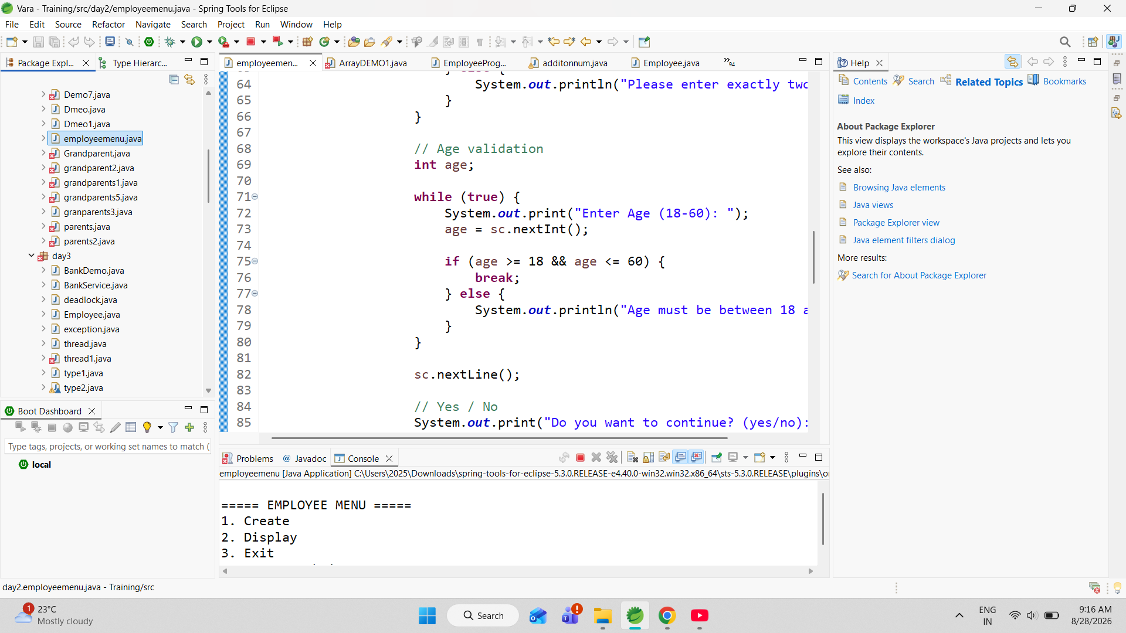

The application demonstrates how Java can be used to combine data, object creation, user input, validation, and program control flow in a single application. The display() method is responsible for showing the stored employee information, while the menu allows the user to perform operations repeatedly without restarting the program. The use of emp != null ensures that the program does not attempt to display employee details before an employee has been created.

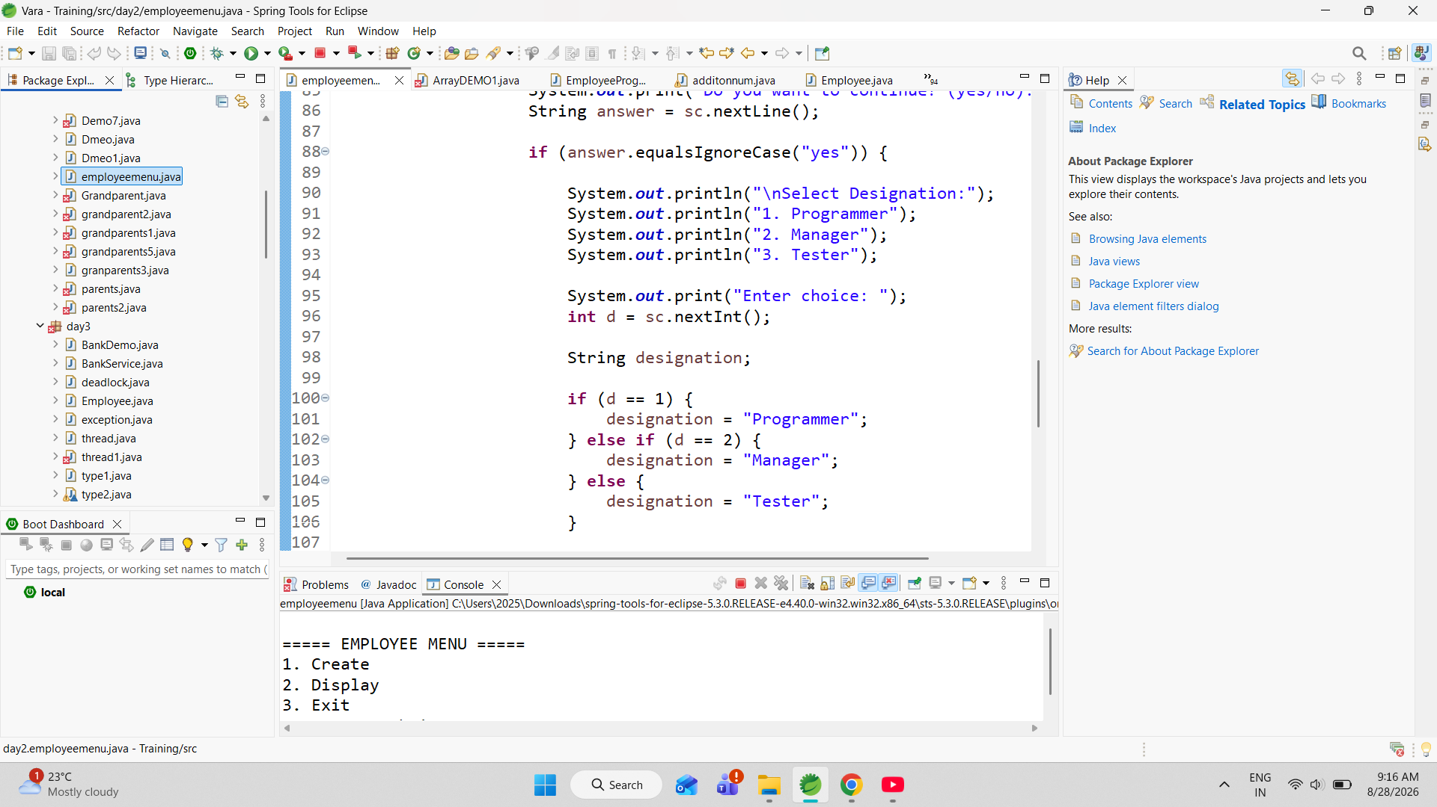

An important feature of the program is input validation. Before creating the employee object, the program checks whether the entered name contains exactly two words. It also verifies that the employee's age is within the allowed range of 18 to 60 years. If invalid information is entered, the program displays an appropriate error message and asks the user to enter the information again. This improves the reliability of the application by preventing incorrect data from being stored.

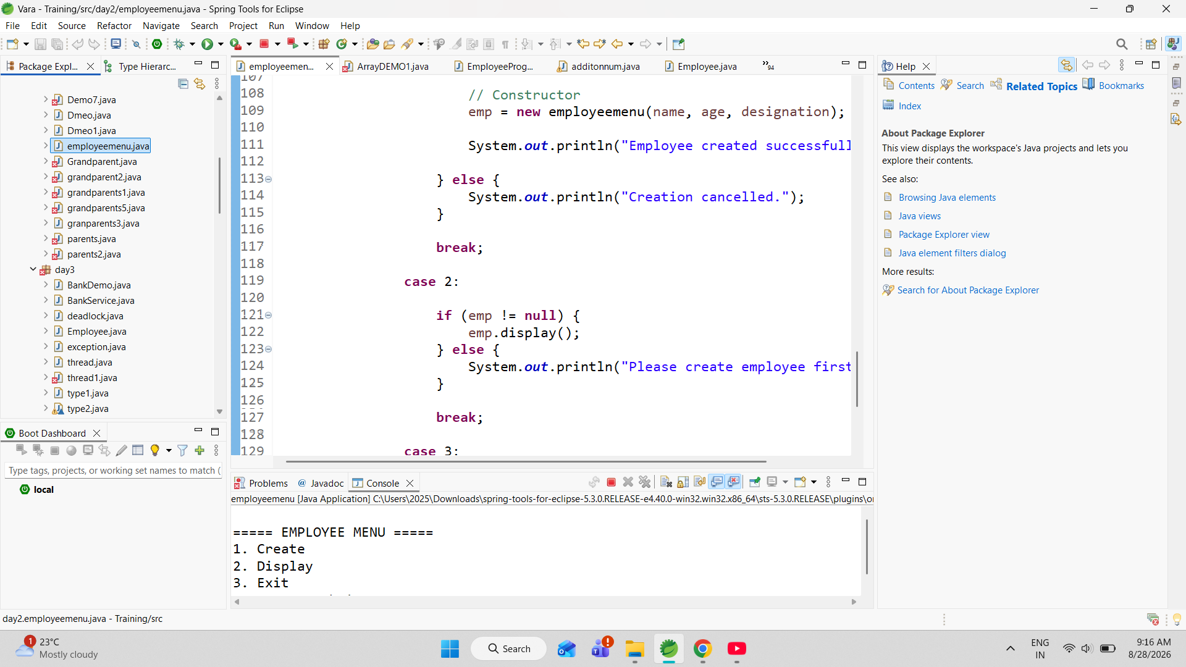

An important feature of the program is input validation. Before creating the employee object, the program checks whether the entered name contains exactly two words. It also verifies that the employee's age is within the allowed range of 18 to 60 years. If invalid information is entered, the program displays an appropriate error message and asks the user to enter the information again. This improves the reliability of the application by preventing incorrect data from being stored.

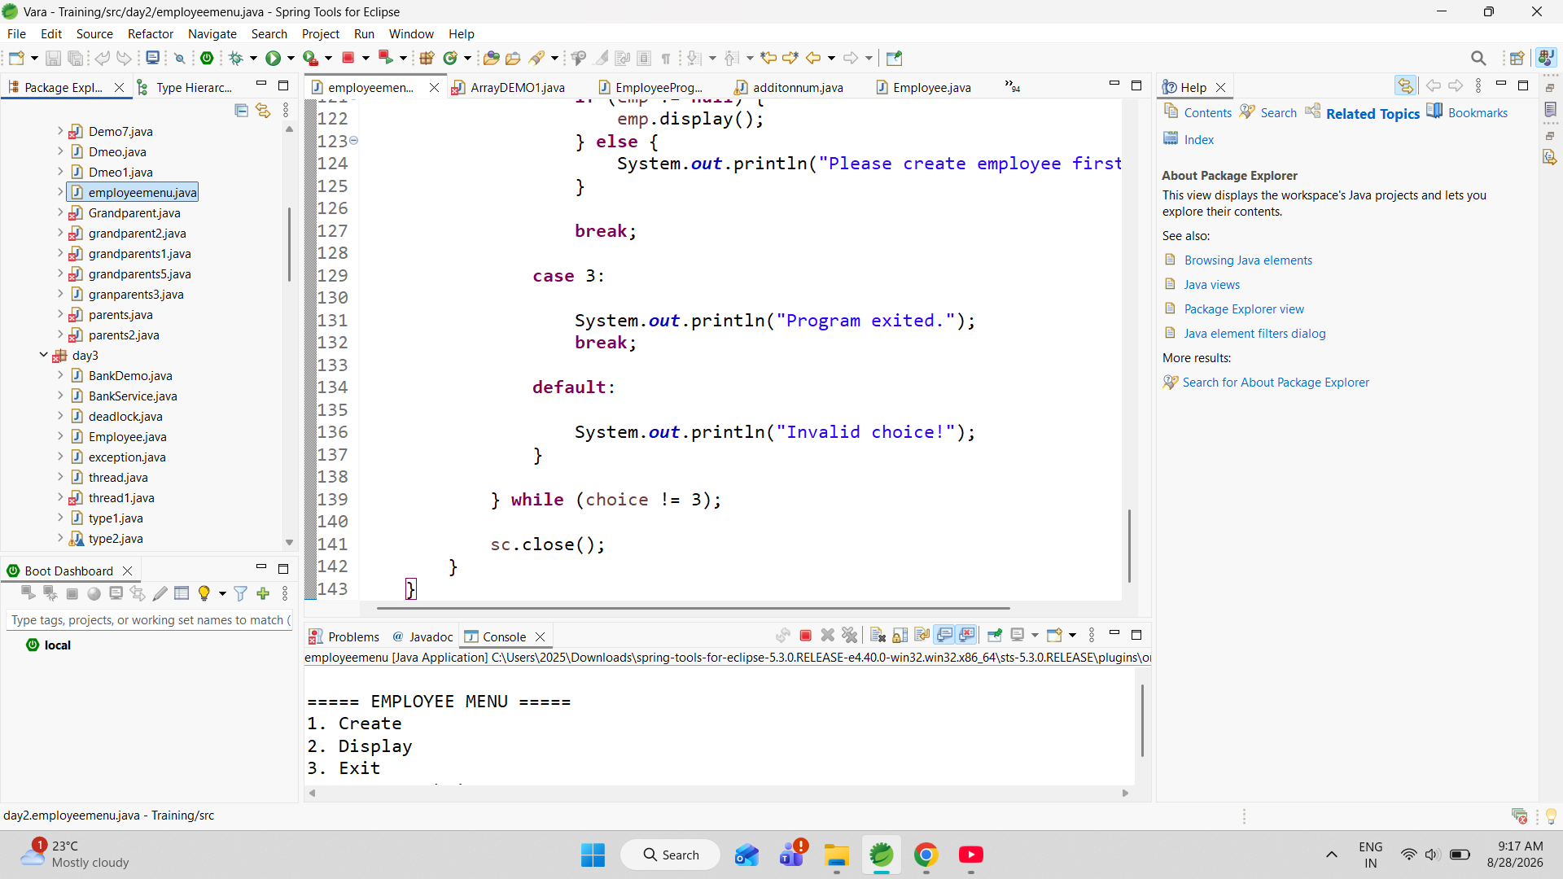

The Employee Salary Management Program is a menu-driven Java application developed to manage employee information and perform basic salary-related operations. The program stores important employee details such as name, age, designation, and salary using instance variables. A parameterized constructor is used to initialize these details when an employee object is created. The program also contains a display() method that shows all the stored employee information in a clear format. It demonstrates important Object-Oriented Programming concepts, including classes, objects, instance variables, constructors, methods, and the this keyword.

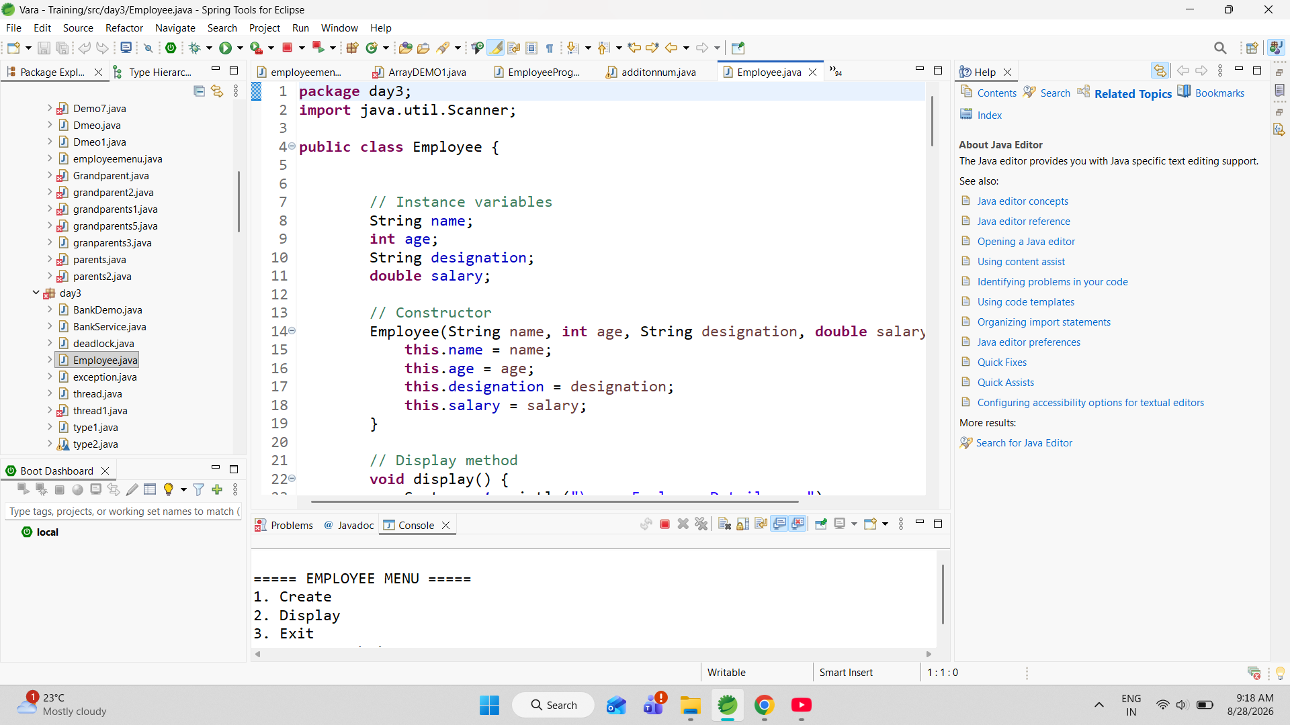

The program uses the Scanner class to accept input from the user through the keyboard. A menu is displayed repeatedly using a do-while loop, allowing the user to perform different operations without restarting the program. The menu contains four options: Create, Display, Raise Salary, and Exit. The Create option collects employee details and validates the age to ensure that it falls within the range of 18 to 60 years. The program also provides a designation selection system in which the user can enter P/p for Programmer, M/m for Manager

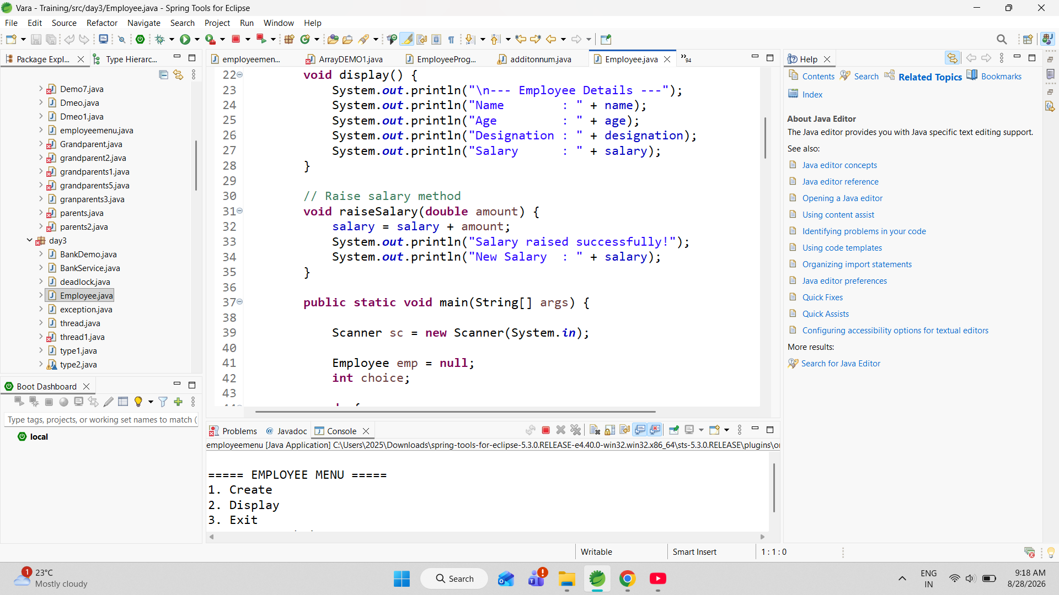

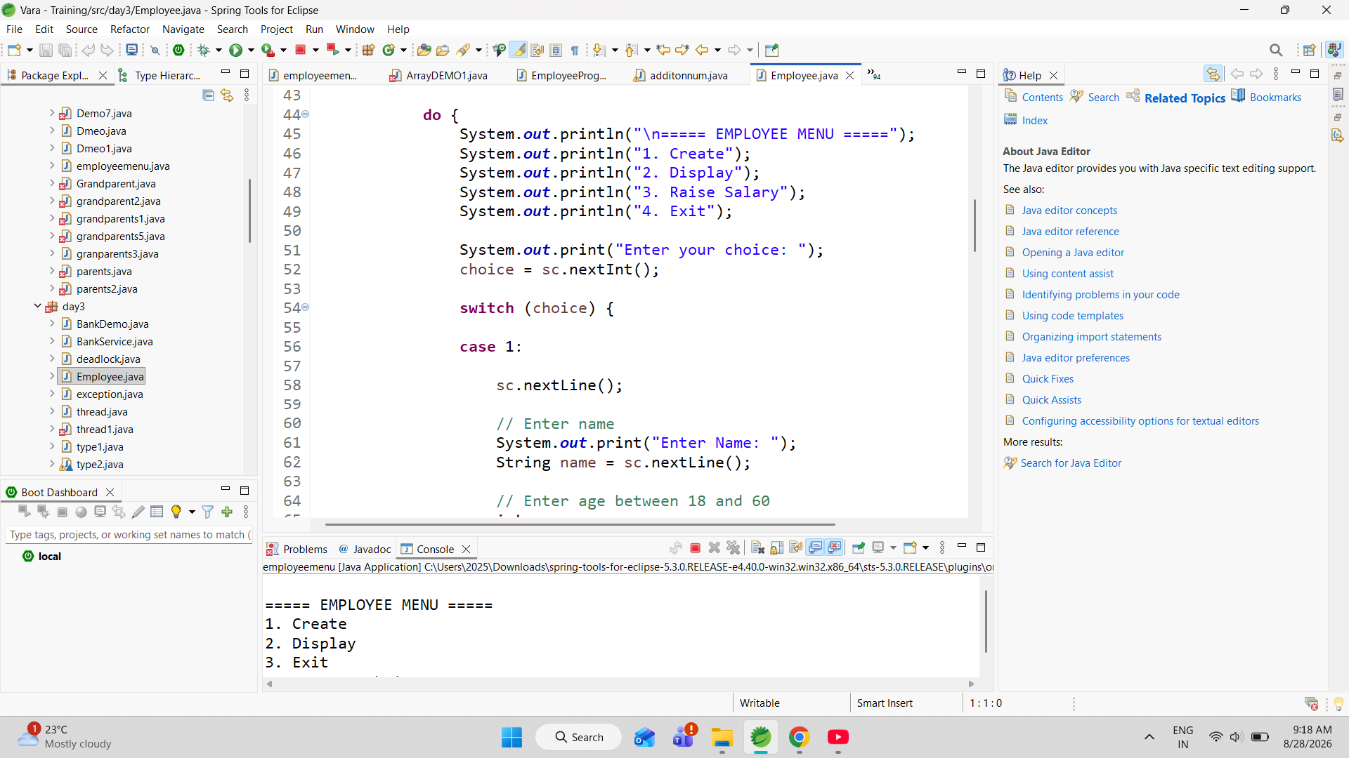

r T/t for Tester. Each designation has a predefined starting salary. A Programmer receives a salary of 20,000, a Manager receives 25,000, and a Tester receives 15,000. If an invalid designation is entered, the program displays an error message and does not create the employee object.

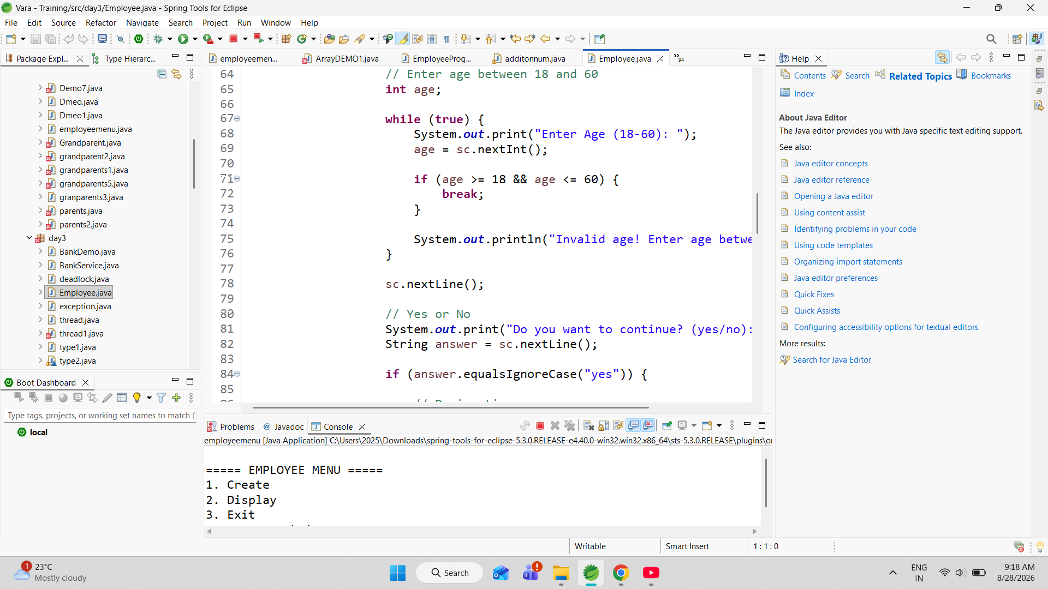

The Display option is used to view the employee's complete information. The program checks whether the employee object exists before displaying the details. This is done using a null check. If an employee has not been created, the program displays a message asking the user to create an employee first. This prevents the program from trying to access an object that has not been initialized. One of the main features of this program is the Raise Salary operation. The raiseSalary() method accepts a salary increase amount as a parameter and adds it to the employee's current salary. For example, if the employee's salary is 20,000 and the user enters a raise amount of 5,000, the new salary becomes 25,000. This demonstrates how methods can be used to modify the data stored inside an object. The program again checks whether an employee exists before performing the salary operation.

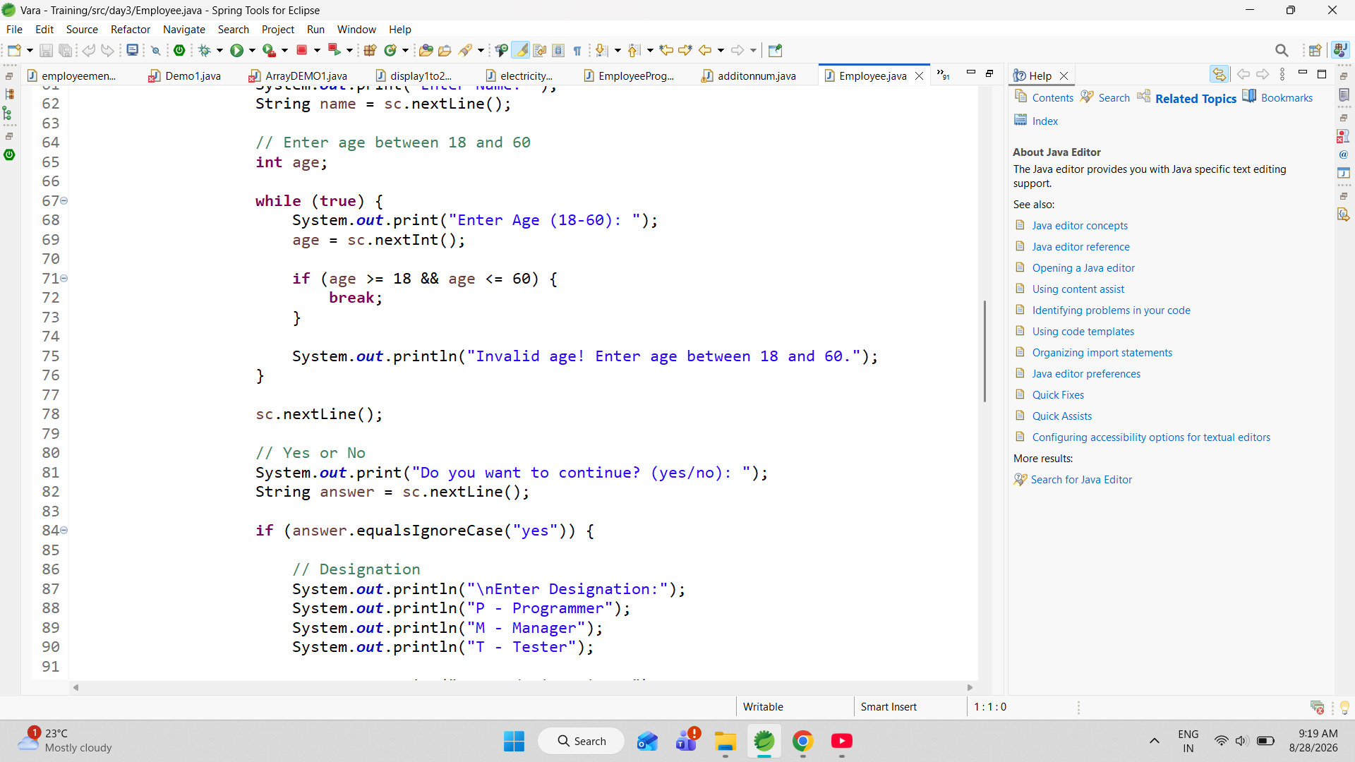

The program also demonstrates several control-flow statements. The switch-case statement is used to process the user's menu selection, while if-else statements are used for designation selection, validation, and object checking. The while loop is used to repeatedly request the age until a valid value is entered. The do-while loop ensures that the main menu continues to appear until the user selects the Exit option. The break statement is used to terminate individual cases and validation loops when the required condition is satisfied.

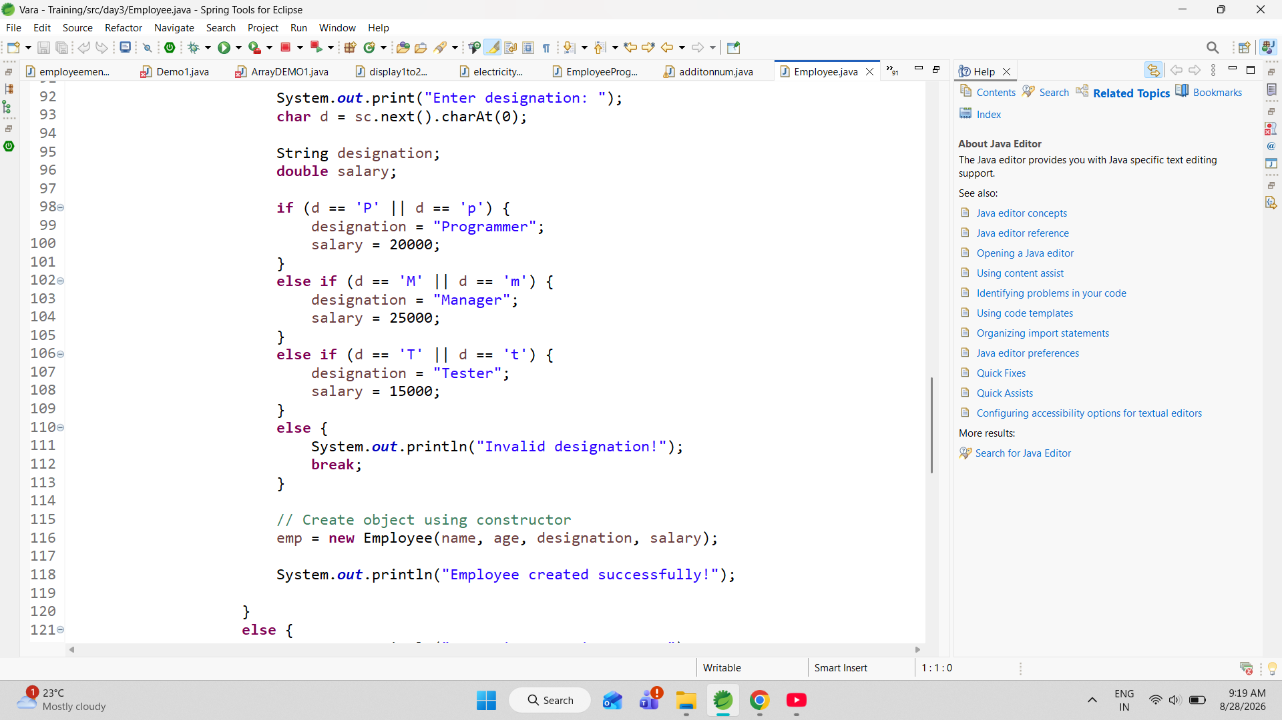

From an OOP perspective, the program demonstrates the relationship between class, object, constructor, instance variables, and methods. The Employee class contains both the employee's data and the operations that can be performed on that data. The constructor initializes the employee, the display() method presents the employee's information, and the raiseSalary() method modifies the salary. This approach provides a simple example of combining data and functionality within a single

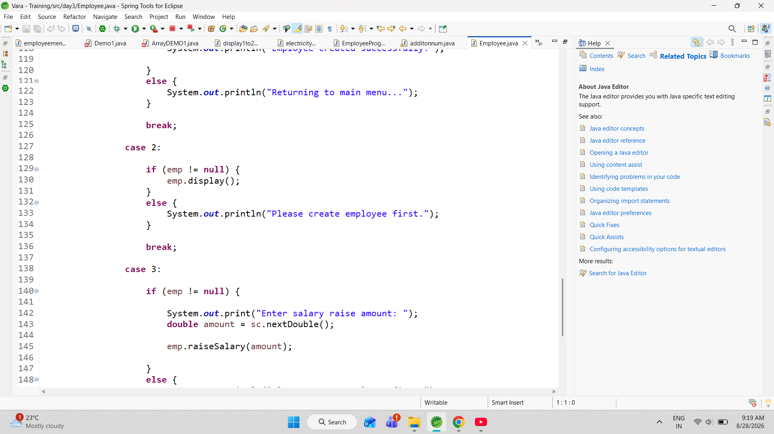

The main objective of this program is to provide a basic system for creating, viewing, and updating employee information, particularly salary details. It also helps demonstrate how validation and menu-driven programming can be used to make a Java application more reliable and interactive. Although the program currently manages only one employee, its structure can be extended to support multiple employees, salary calculations, employee searching, updating details, deleting employees, storing records in files or databases, and generating employee reports.

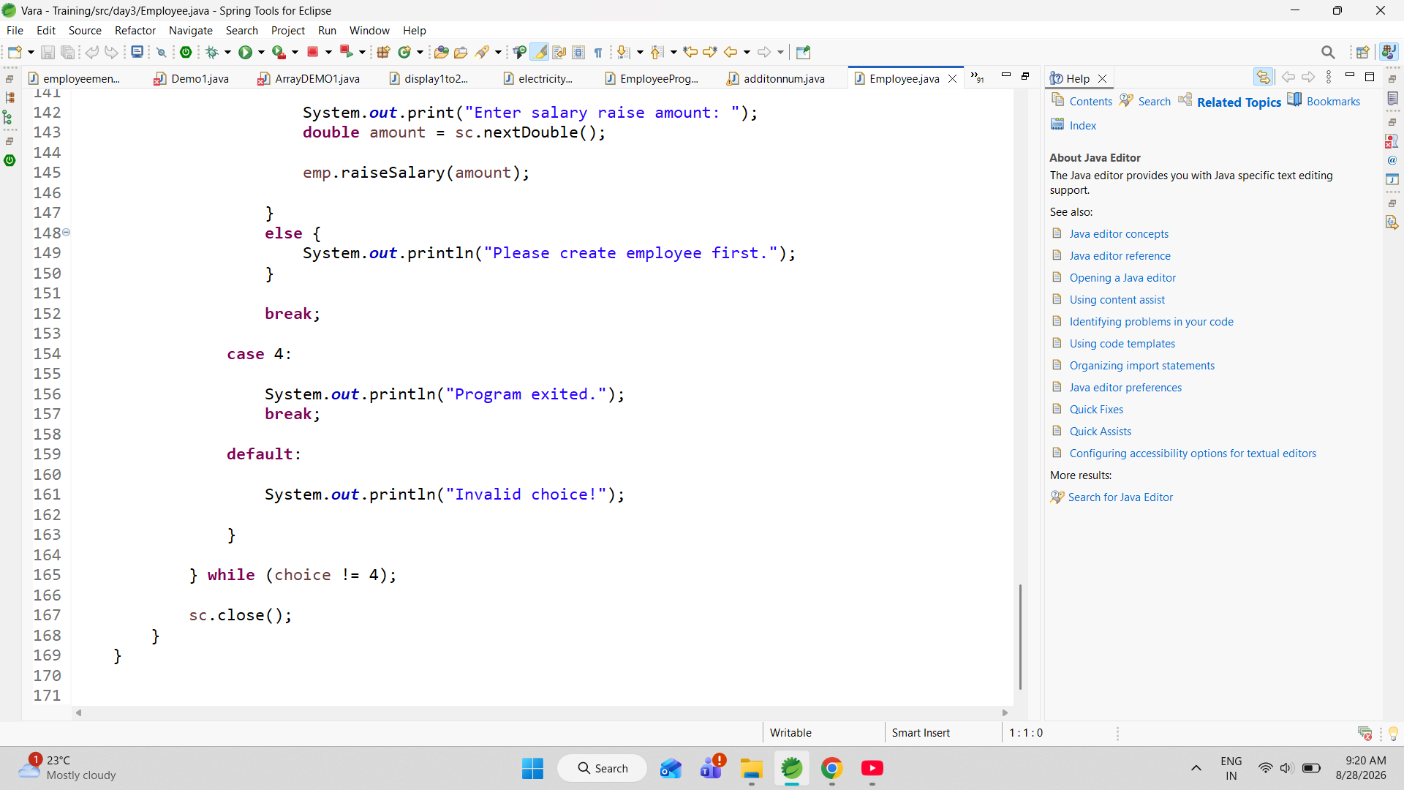

In conclusion, the Employee Salary Management Program is a practical example of applying fundamental Java concepts to a real-world problem. It combines OOP principles, constructors, objects, methods, user input, validation, loops, conditional statements, switch-case, and arithmetic operations to create a simple employee management system. The program provides a strong foundation for developing more advanced employee-management applications in the future.

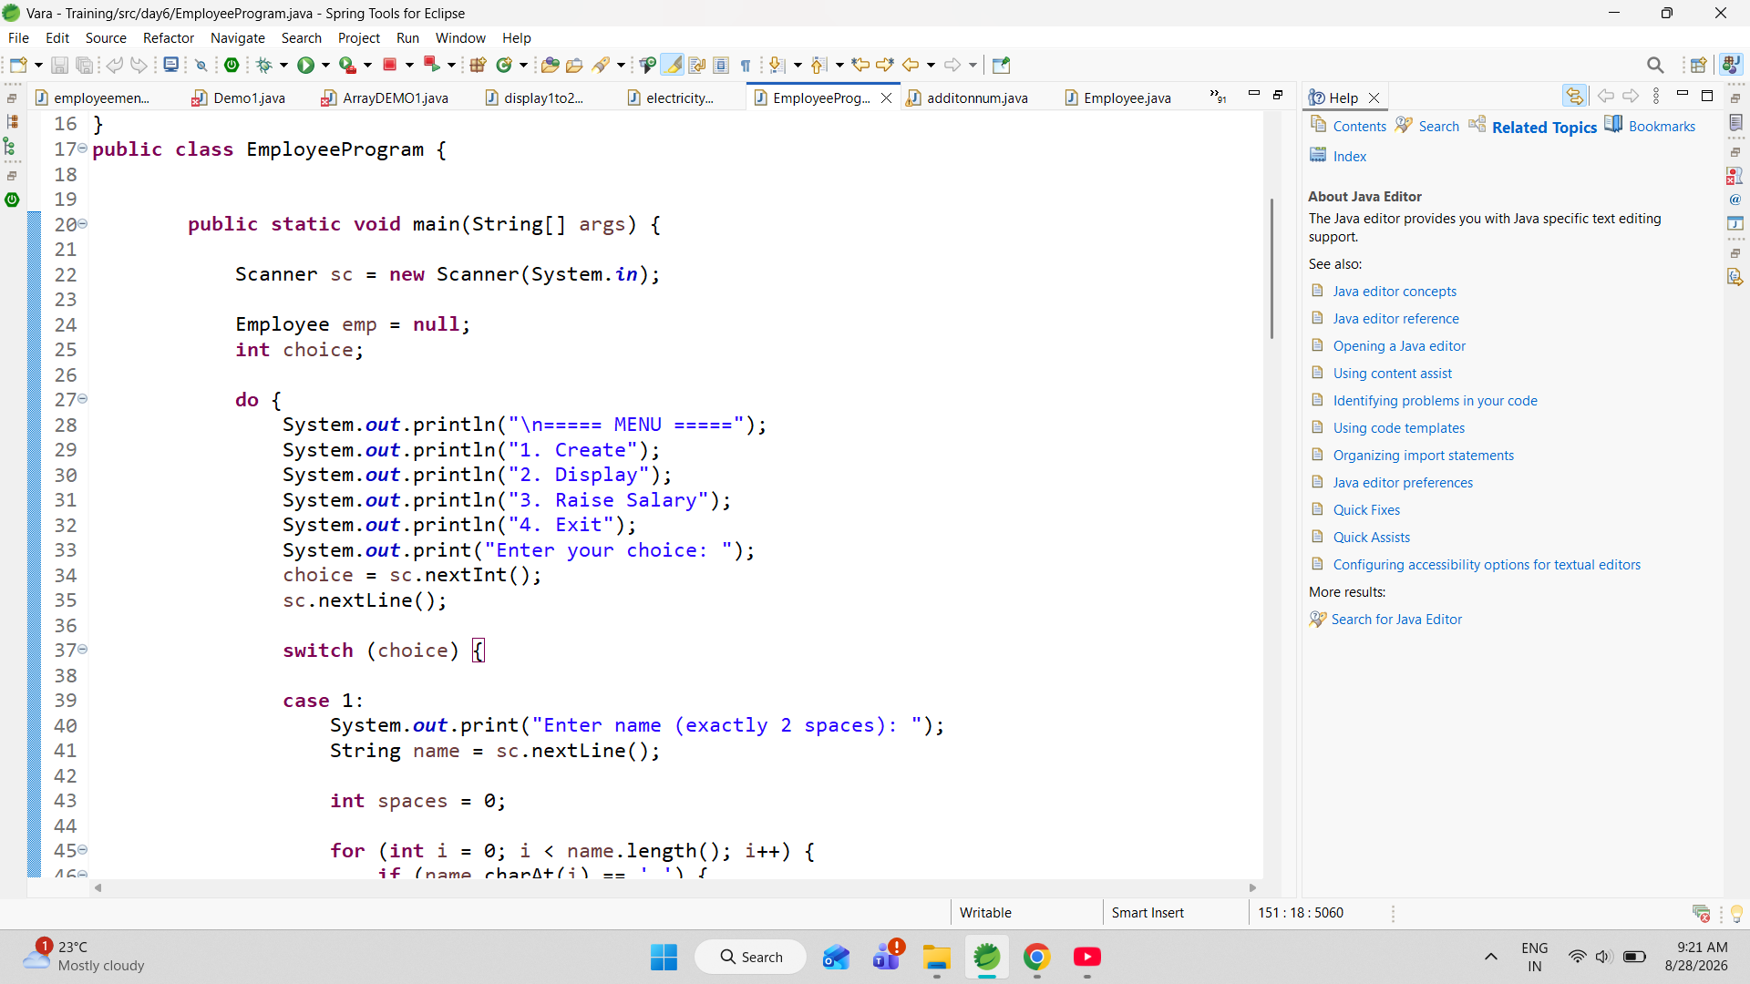

he Employee Program is a menu-driven Java application developed to create, display, and update the salary of an employee. The program uses an Employee class to store important employee information such as name, age, designation, and salary. These are represented using instance variables.The this keyword is used inside the constructor to refer to the current employee object. The program demonstrates basic Object-Oriented Programming concepts, including classes, objects, constructors, instance variables, and object initializati

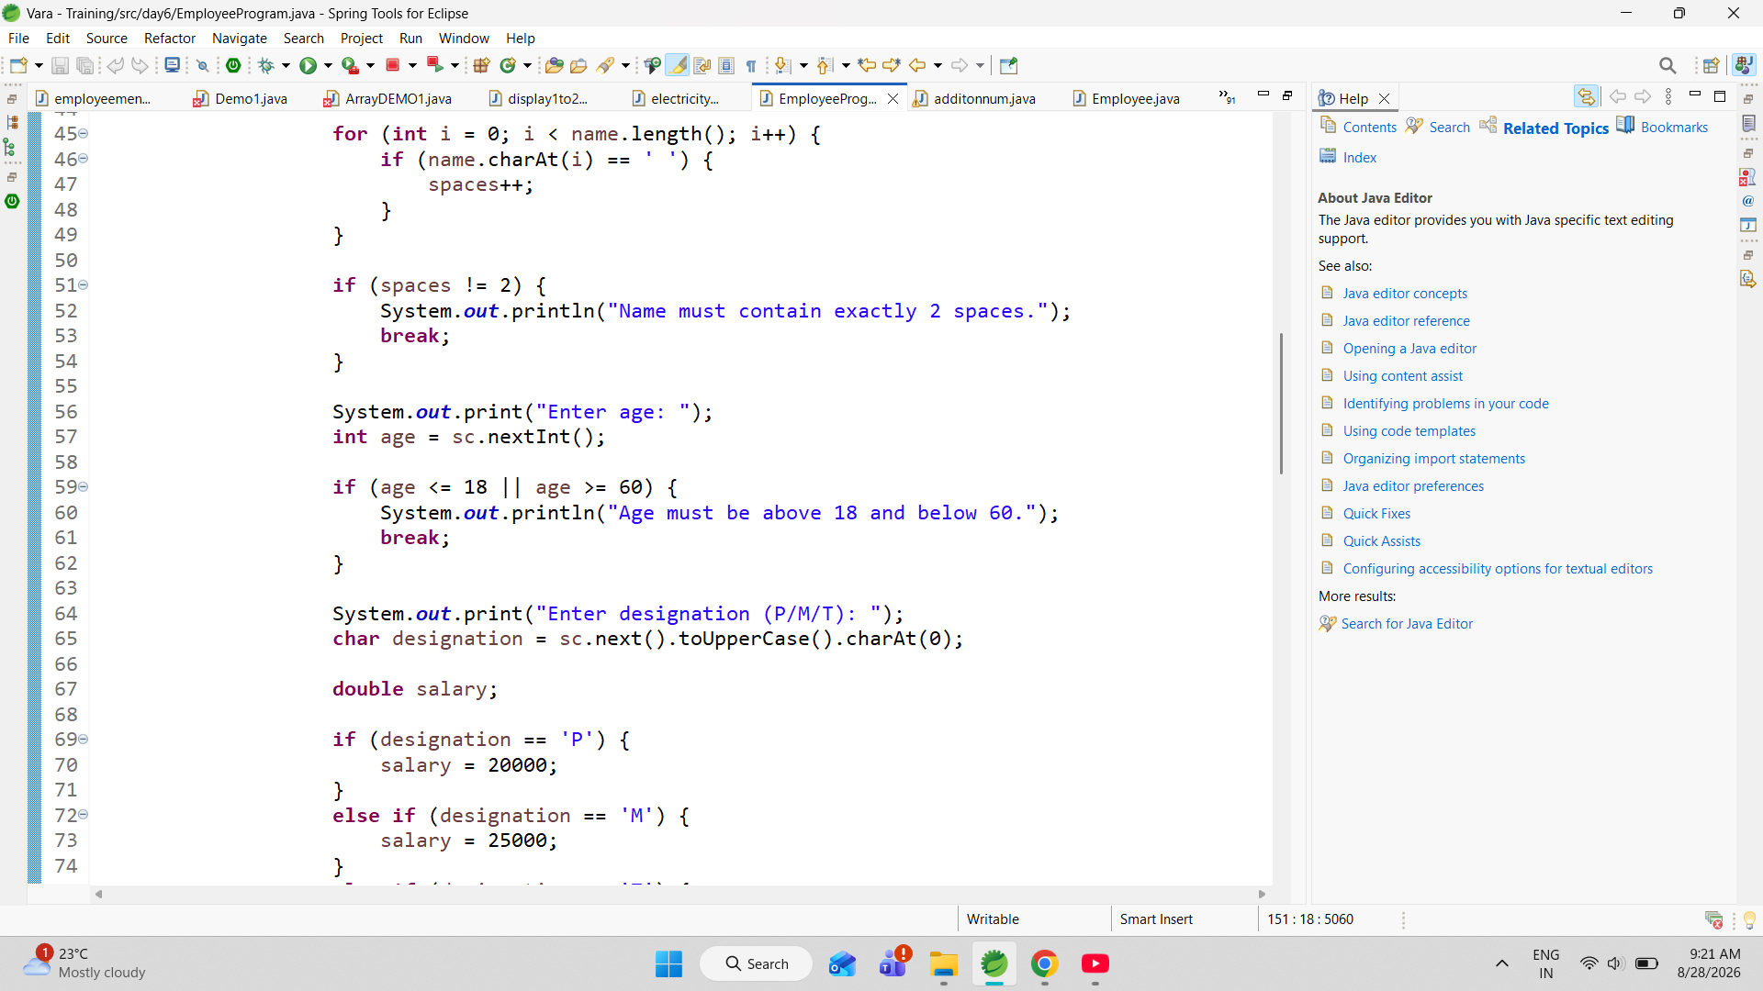

The application starts by displaying a menu containing four options: Create, Display, Raise Salary, and Exit. The Create operation collects employee information from the user and performs several validation checks before creating the object. The name is checked by counting the number of spaces using a for loop, and the program accepts the name only when it contains exactly two spaces. The age is also validated to ensure that it is greater than 18 and less than 60. The user then enters a designation using P, M, or T, which represents Programmer, Manager, or Tester. According to the selected designation, the program assigns a predefined salary of 20,000 for Programmer, 25,000 for Manager, and 15,000 for Tester.

.

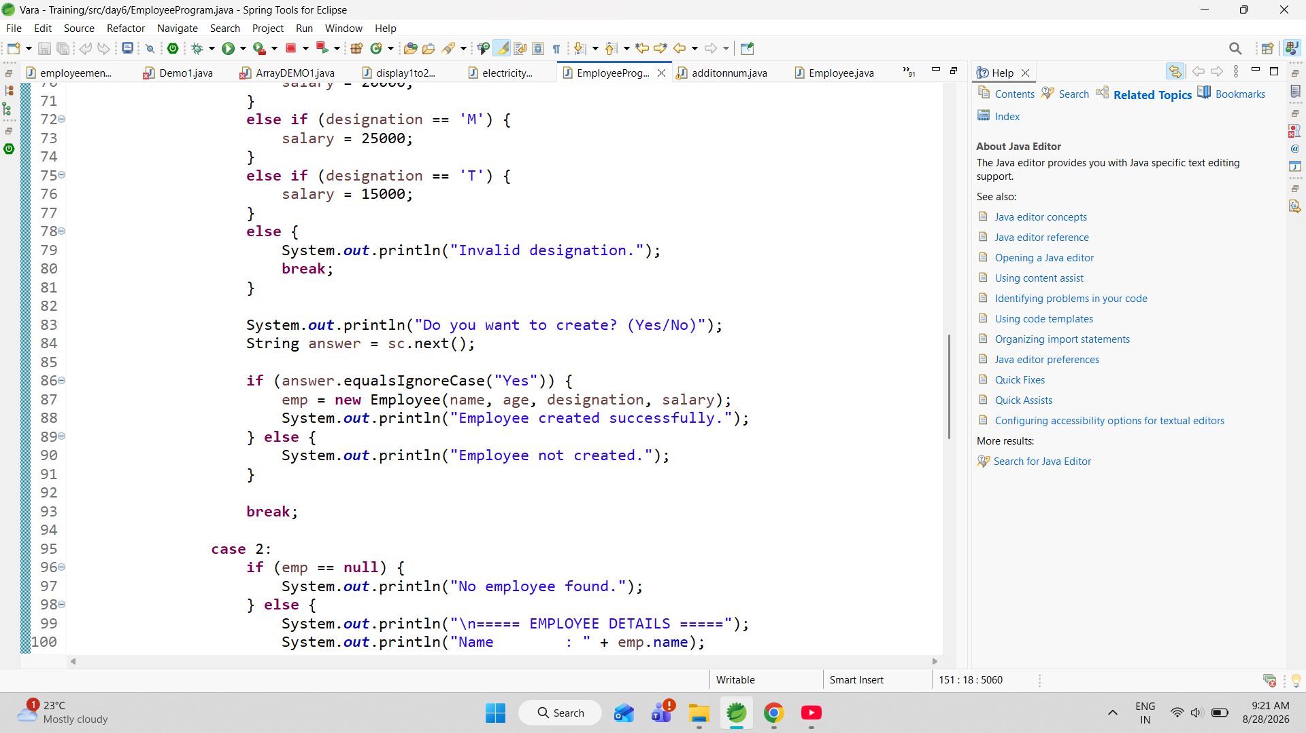

After entering the employee details, the program asks the user for confirmation before creating the employee object. If the user enters Yes, an Employee object is created using the new keyword and the constructor. If the user selects No, the employee is not created and the program returns to the main menu. This confirmation step ensures that the employee is created only after the user verifies the entered information.

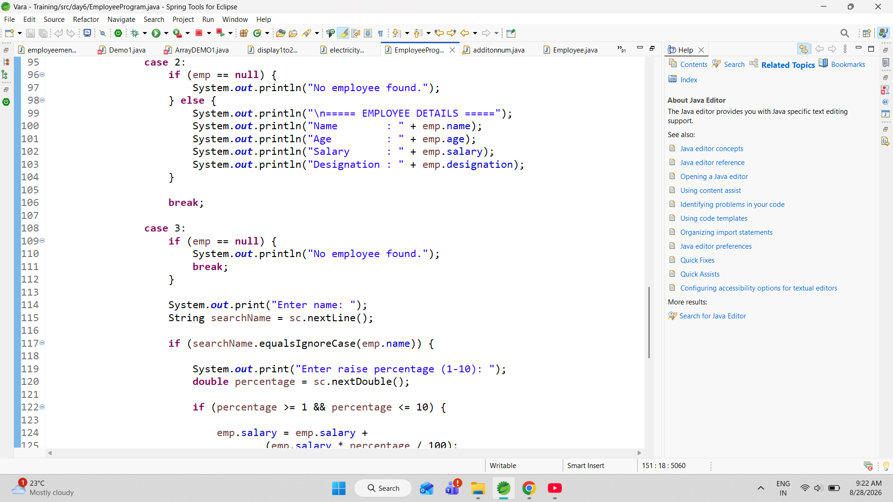

The Display operation is used to retrieve and show the details of the employee. Before displaying the information, the program checks whether the employee reference is null. If no employee has been created, it displays "No employee found." Otherwise, it displays the employee's name, age, salary, and designation. This null check helps prevent the program from attempting to access data from an object that does not exist.

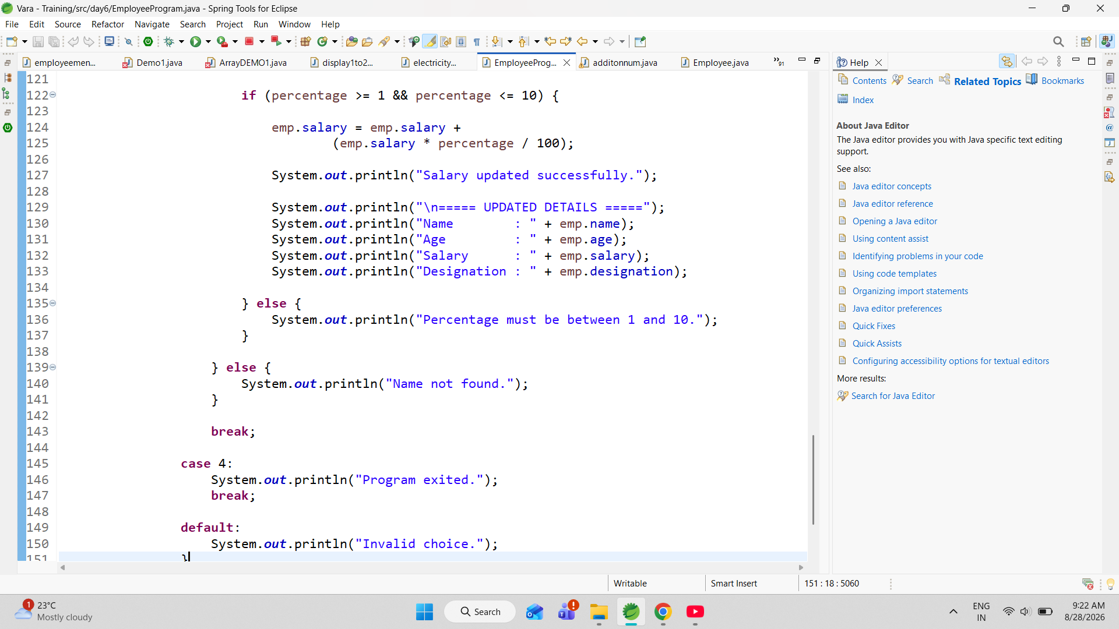

he Raise Salary operation is another important feature of the program. Before modifying the salary, the program checks whether an employee exists. It then asks the user to enter the employee's name and compares it with the stored employee name using equalsIgnoreCase(). This allows the name comparison to be performed without considering uppercase or lowercase differences. If the entered name matches, the program asks for a salary raise percentage between 1% and 10%. The salary is then calculated using a percentage formula and added to the existing salary.

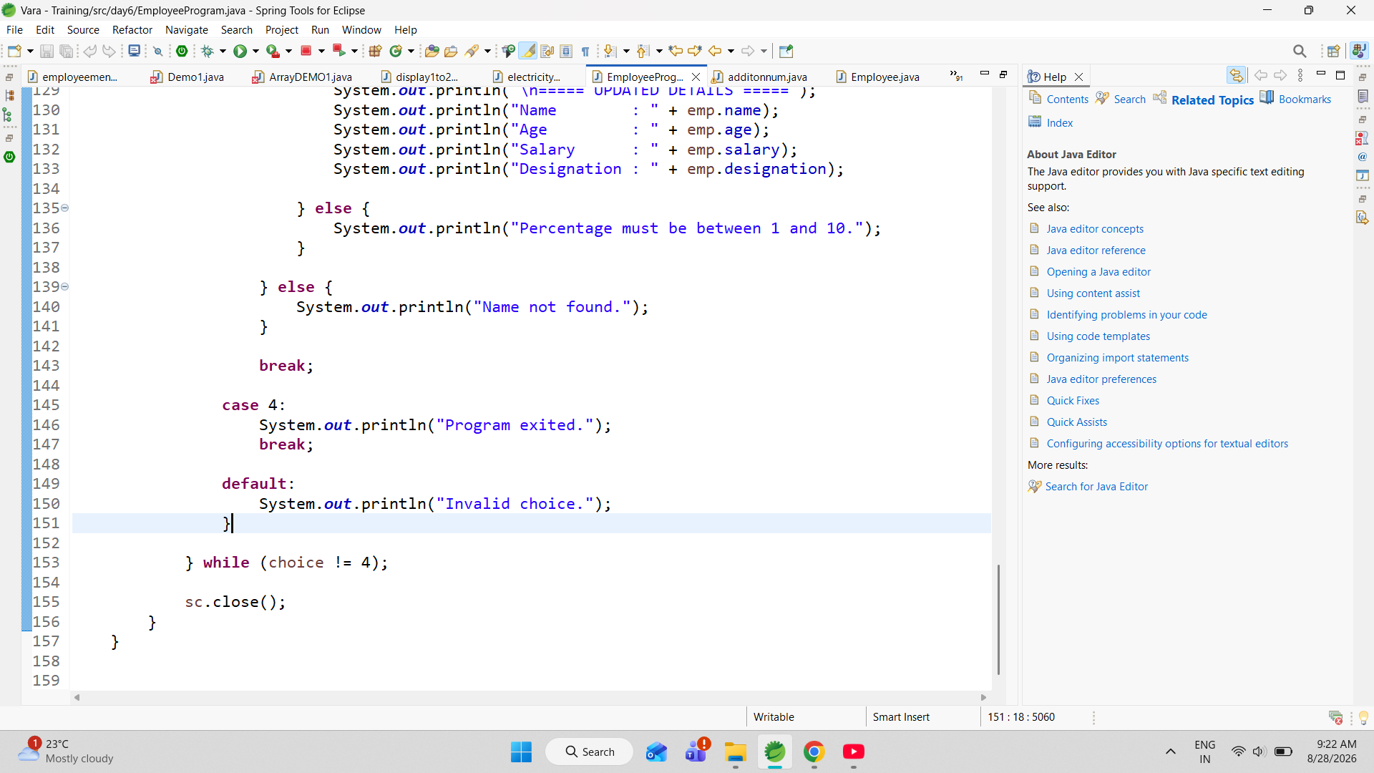

Overall, the Employee Program is a practical example of a basic employee management system using Java. It combines object-oriented programming with input validation, menu-driven operations, string handling, loops, conditional statements, and mathematical calculations. The program currently manages a single employee, but its structure can be extended to manage multiple employees and provide additional features such as searching, updating employee details, deleting records, calculating bonuses, generating reports, and storing employee data permanently.

